**Sample Midterm 1 quiz**

* Due No due date
* Points 0
* Questions 10
* Time Limit None
* Allowed Attempts Unlimited

**Attempt History**

|  | **Attempt** | **Time** | **Score** |
| --- | --- | --- | --- |
| **LATEST** | [Attempt 1](https://canvas.colorado.edu/courses/53898/quizzes/82269/history?version=1) | 86 minutes | 0 out of 0 * |

*\** Some questions not yet graded

Submitted Oct 13 at 10pm

Question 1

0 / 0 pts

HAVING is to GROUP BY as WHERE is to SELECT

Correct!

True

False

Question 2

Not yet graded / 0 pts

Study the Data Model below, and then construct a SQL query to answer this question:  How many different countries are represented by the customers in the "customers" table?

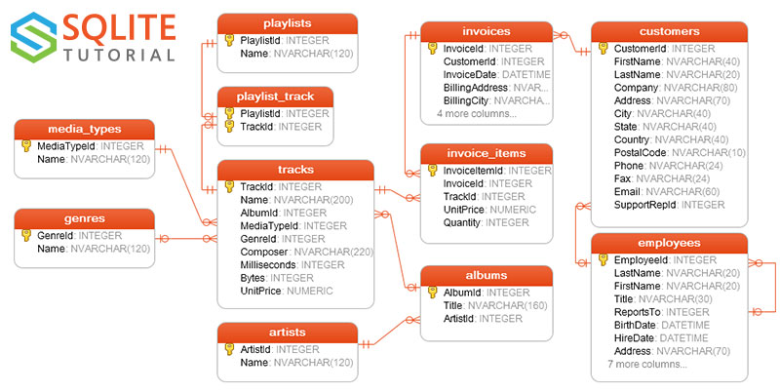

Your Answer:

SELECT DISTINCT COUNT (countries) from customers.

Question 3

0 / 0 pts

People often display images on their web pages which are of two different types of files:  .jpg and .gif.  Which of the following statements comparing .gif files to .jpg files is NOT true.

gif files support animation while jpg files do not.

Correct Answer

jpg files compress nicely while gif files lose quality when compressed

You Answered

gif files are restricted to only 256 colors while jpg files can display millions of colors.

gif files are often used for illustrations, while jpg files are often used for photographs.

Question 4

0 / 0 pts

The linux command  “>”

compares two files and displays all the differences

does nothing. “>” is NOT a linux command.

compares two files to see which one is larger

Correct!

redirects the output of a command into a file

Question 5

0 / 0 pts

During a daily scrum, sprint team members take turns answering which of these questions (mark all that apply.)

What features are in the next sprint?

Correct!

What have I completed since the last scrum?

Correct!

What obstacles are blocking my progress?

Correct!

What will I complete by the next scrum?

Question 6

0 / 0 pts

Which statement below BEST describes the principle depicted in this image?

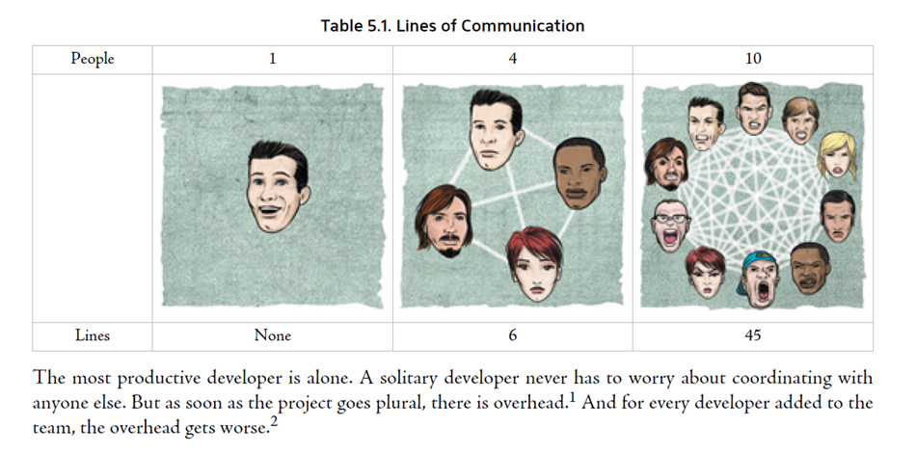

People don't communicate well if they come from different backgrounds.

You Answered

Teams should never have more than 10 members.

Correct!

The larger a team gets, the more difficult it is to maintain good communication.

You Answered

Teams should never have more than 10 members.

Question 7

0 / 0 pts

Which of the following is not a valid git command?

git diff

Correct Answer

git drop

You Answered

git checkout

git commit

Question 8

0 / 0 pts

Which of the following HTML tags is used to embed a link within your page that, when clicked, will open up another web page?

You Answered

<href>

<hypertext>

Correct Answer

<a>

<link>

Question 9

0 / 0 pts

How do you list all files with names having g, i or r in the 3rd place of the filename?

None of these

ls ..[gir]*

ls ?3[gir]*

ls ..{gir}*

You Answered

ls \3[gir]*

ls *[gir]*

ls [..igr*]

Correct Answer

ls ??[gir]*

Question 10

0 / 0 pts

Which of the following commands sends your local work to the remote server?

git add

Correct!

git push

git commit

git pull